WEEK 3 REPORT

Endpoint Monitoring, Log Analysis & network Intrusion Detection

Cybersecurity Internship Weekly Report

Prepared By | Devangi Khatri
Program | DG Interns Hub
Reporting Period | Week 3
Focus | Endpoint Monitoring, Log Analysis & network Intrusion Detection
Submission deadline | 6th November 2026, 11:59 PM IST

1. Introduction
During Week 3 of the cybersecurity internship, I focused on understanding endpoint monitoring, Linux auditing, network intrusion detection and security log analysis.
The main objective was to understand how SOC analysts monitor Windows and Linux systems, identify suspicious activities and detect potential network attacks.
I worked with different security tools, including Sysmon, Linux auditd and Snort. I also explored security monitoring concepts, SIEM platforms and MITRE ATT&CK techniques.
This week's activities helped me understand how endpoint and network logs are collected, monitored and analyzed during security investigations.
2. Objectives
The main objectives of Week 3 were:
- Understand Endpoint Detection and Response (EDR).
- Learn Windows endpoint monitoring using Sysmon.
- Understand Linux system auditing using auditd.
- Identify and analyze important Linux log files.
- Install and configure Snort IDS/IPS.
- Create custom Snort detection rules.
- Detect network scanning activities using Nmap.
- Understand MITRE ATT&CK T1046.
- Learn log ingestion and SIEM monitoring.
- Understand signature-based and anomaly-based detection.
- Develop practical SOC monitoring and investigation skills.

3. Theoretical Learning
I completed the theoretical learning activities covering the following topics.
3.1 Endpoint Detection and Response (EDR)
- Learned what EDR is and why it is important in cybersecurity.
- Understood how endpoint data helps SOC analysts investigate suspicious activities.
- Studied the difference between traditional antivirus and EDR.
- Learned how endpoint monitoring helps identify malicious processes, file changes and network connections.
3.2 Windows Sysmon
- Learned about Microsoft Sysmon and its functionality.
- Understood how Sysmon records detailed Windows system activities.
- Studied important Sysmon Event IDs.
Important Event IDs:
Event ID | Description
1 | Process Create
3 | Network Connection
11 | File Create
13 | Registry Value Set
22 | DNS Query
3.3 Linux auditd
- Learned the purpose of Linux auditd.
- Understood how auditd monitors system activities.
- Studied audit logs and their important fields.
- Learned how to search audit records using ausearch.
- Understood the difference between auditd and syslog.

3.4 Snort IDS/IPS
- Learned the working of Snort.
- Studied IDS and IPS modes.
- Understood how Snort analyzes network packets.
- Learned how detection rules generate alerts.
- Studied Snort rule structure and important rule options.
3.5 MITRE ATT&CK T1046
- Studied Network Service Discovery.
- Understood how attackers identify available network services.
- Learned how Nmap scanning activity can be detected.
- Understood how Snort detection rules can be mapped to MITRE ATT&CK techniques.

3.6 Other Topics
I also studied:
- Signature-based detection.
- Anomaly-based detection.
- Windows Event Logs vs Sysmon vs Linux auditd.
- Important Linux log files.
- Log ingestion.
- SIEM monitoring using Wazuh and Splunk.

4. TryHackMe Practical Learning
I completed the following TryHackMe rooms to improve my understanding of Linux logging, log analysis and network intrusion detection
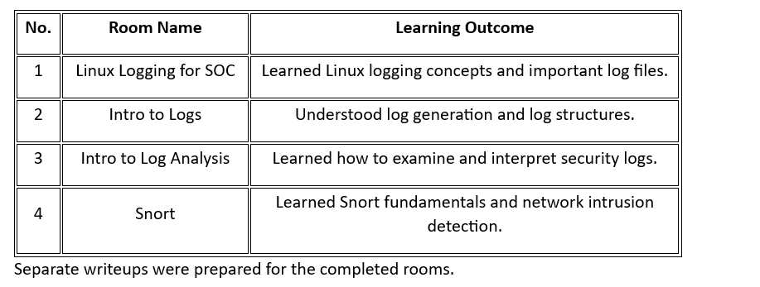

5. LetsDefend Practical Learning
I completed the following LetsDefend training lessons.
No. | Lesson Name | Learning Outcome
1 | How to Investigate a SIEM Alert | Learned the basic SIEM alert investigation process.
2 | Security Solutions | Learned about different cybersecurity security solutions.
3 | Network Log Analysis | Understood network log analysis.
4 | SIEM 101 | Learned SIEM fundamentals and monitoring concepts.
5 | Incident Management | Understood security incident management.
6 | Incident Response on Linux | Learned Linux incident response fundamentals.

6. Hands-On Practical Implementation
6.1 Installing Sysmon on Windows
Objective: Install Sysmon to monitor Windows endpoint activities.
Activities performed:
- Downloaded Sysmon from the Microsoft Sysinternals source.
- Extracted the installation files.
- Downloaded the SwiftOnSecurity Sysmon configuration.
- Installed Sysmon using an elevated Command Prompt.
- Verified Sysmon installation through Windows Event Viewer.
- Accessed the Sysmon Operational event log.
Learning Outcome:
Understood how Sysmon collects detailed endpoint information and records system activities for security monitoring.
6.2 Generating and Analyzing Sysmon Events
Performed different activities on the Windows VM to generate Sysmon events.
Activities:
- Opened PowerShell.
- Created a new user account.
- Checked network connections.
- Created a text file.
- Located the corresponding events in Event Viewer.
Important events analyzed:
- Event ID 1 – Process Create.
- Event ID 3 – Network Connection.
- Event ID 11 – File Create.
For each event, the relevant details included:
- Event ID.
- Timestamp.
- Process image.
- Command line.
- User information.
- Source and destination IP addresses, where available.
- Target filename, where applicable.
Learning Outcome:
Learned how SOC analysts use Sysmon events to investigate process execution, network connections and file creation activities.
6.3 Linux Auditing Using auditd
Objective: Monitor and analyze Linux system activities using auditd.
Activities performed:
- Installed auditd on the Ubuntu VM.
- Enabled and started the auditd service.
- Verified the service status.
- Executed Linux commands.
- Used ausearch to search audit records.
- Examined audit log entries.
Learning Outcome:
Learned how Linux audit logs record system activities and how security analysts investigate command execution and user activity

6.4 Installing and Configuring Snort
Objective: Configure Snort to monitor network traffic and detect suspicious activities.
Activities performed:
- Updated Ubuntu package repositories.
- Installed Snort and its required packages.
- Verified Snort installation.
- Identified the network interface using ip a.
- Configured HOME_NET and EXTERNAL_NET.
- Opened the local.rules configuration file.
- Added custom detection rules.
- Tested the Snort configuration.
Custom Snort Rules
Rule 1 – ICMP Ping Detection
alert icmp any any -> $HOME_NET any (msg:"ICMP Ping Detected"; sid:1000001; rev:1;)
Rule 2 – SSH Connection Attempt
alert tcp any any -> $HOME_NET 22 (msg:"SSH Connection Attempt"; sid:1000002; rev:1;)
Rule 3 – HTTP Traffic Detection
alert tcp any any -> $HOME_NET 80 (msg:"HTTP Traffic"; sid:1000003; rev:1;)
Learning Outcome:
Learned how Snort inspects network traffic and generates alerts based on configured detection rules.

6.5 Nmap SYN Scan Detection
Objective: Detect network scanning activity using Snort and map the detection to MITRE ATT&CK T1046.
Created an advanced Snort rule to identify repeated TCP SYN packets.
Important rule components:
- flags:S – Matches TCP SYN packets.
- threshold – Controls alert frequency.
- classtype:attempted-recon – Classifies reconnaissance activity.
- metadata:mitre_technique T1046 – Associates the rule with MITRE ATT&CK T1046.
- sid:1000004 – Identifies the custom rule.
Test activity:
- Used Nmap from Kali Linux.
- Performed a SYN scan against the lab target.
- Monitored Snort alerts.
- Examined the detection rule and its MITRE mapping.
Learning Outcome:
Understood how network scanning activities can be detected through Snort rules and how security detections can be mapped to MITRE ATT&CK.

7. Security Event ID and Rule Cheat Sheet
Prepared a cheat sheet containing more than 15 important Windows, Sysmon, Linux auditd and Snort events.
The cheat sheet includes:
- Event ID or Rule.
- Source.
- What it means.
- When to use it.
Important examples:
Event ID / Rule | Source | Description
4624 | Windows Security | Successful logon
4625 | Windows Security | Failed logon
4688 | Windows Security | Process creation
4720 | Windows Security | New user account
1 | Sysmon | Process Create
3 | Sysmon | Network Connection
11 | Sysmon | File Create
22 | Sysmon | DNS Query
EXECVE | auditd | Command execution
USER_LOGIN | auditd | User login
USER_AUTH | auditd | Authentication attempt
1000001 | Snort | ICMP Ping Detection
1000002 | Snort | SSH Connection Attempt
1000003 | Snort | HTTP Traffic
1000004 | Snort | Nmap SYN Scan Detection

8. Tools and Technologies Used
Tool / Technology | Purpose
Windows 10/11 | Endpoint monitoring environment
Sysmon | Windows event monitoring
Event Viewer | Windows log analysis
Ubuntu Linux | Linux auditing environment
auditd | Linux security auditing
ausearch | Searching audit records
Snort | Network intrusion detection
Kali Linux | Security testing and Nmap scanning
Nmap | Network discovery and port scanning
TryHackMe | Cybersecurity practical learning
LetsDefend | SOC analyst training
Wazuh / Splunk | SIEM concepts and monitoring

9. Skills Developed
During Week 3, I improved my knowledge and practical understanding of:
- Windows endpoint monitoring.
- Linux log analysis.
- Sysmon event investigation.
- Linux audit log analysis.
- Network intrusion detection.
- Snort rule creation.
- Nmap scanning detection.
- MITRE ATT&CK mapping.
- SIEM fundamentals.
- SOC monitoring and incident investigation.

10. Practical Findings and Evidence
The following evidence should be included in the final submission:
- Sysmon installation screenshot.
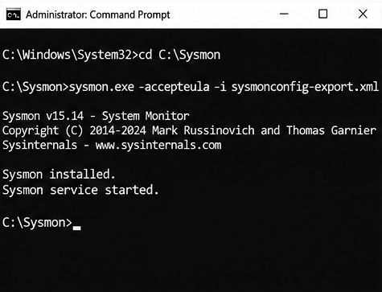

- Sysmon Event ID 1 screenshot.
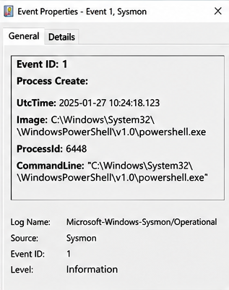

- Sysmon Event ID 3 screenshot.
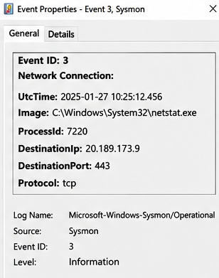
- Sysmon Event ID 11 screenshot.
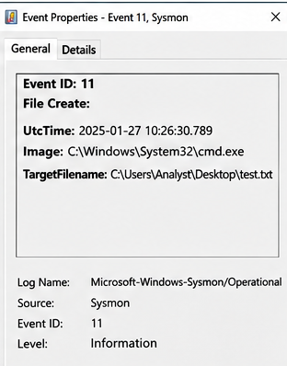

- Linux auditd installation and service status screenshot.
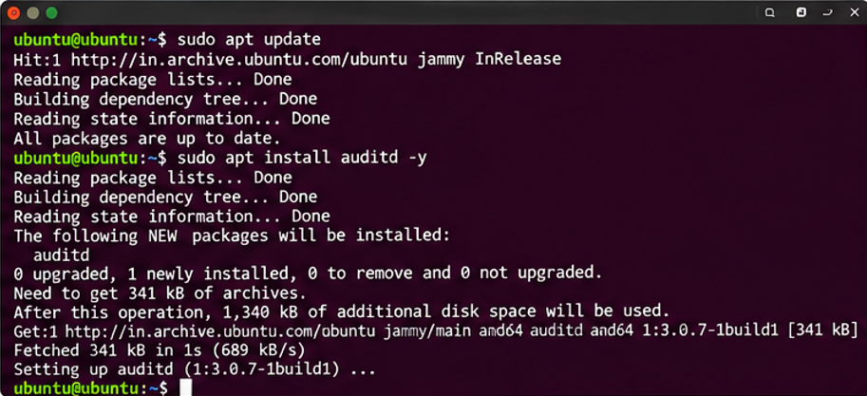

- auditd ausearch output screenshot.
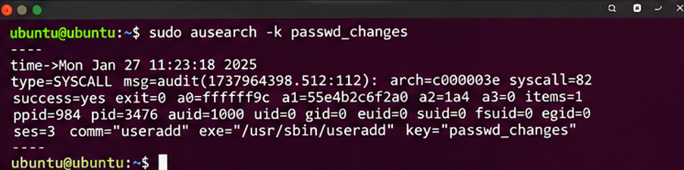

- Snort installation and configuration screenshot.
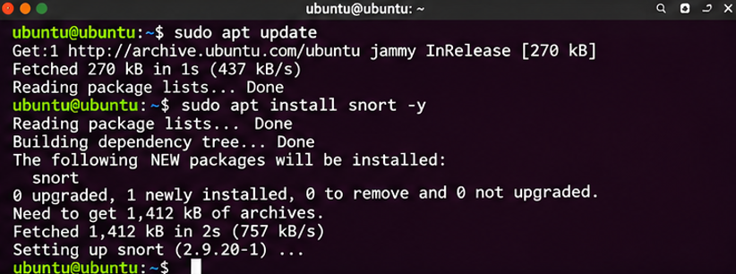

- Snort ICMP , SSH , HTTP alert screenshot.
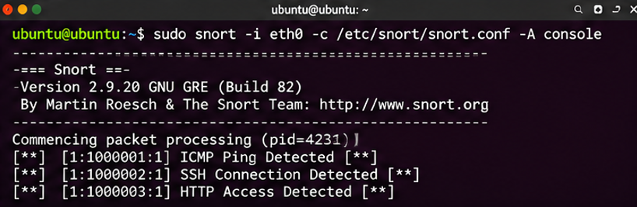
- Nmap SYN scan output
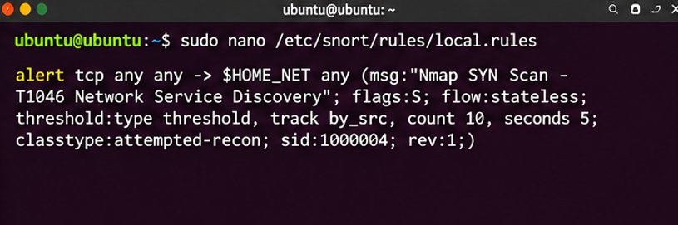

- Snort T1046 detection alert.
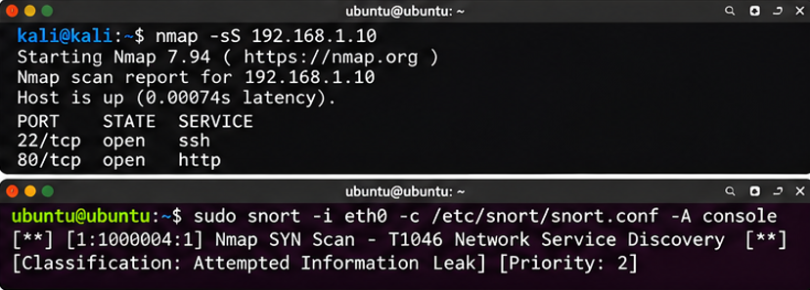

11. Conclusion
Week 3 provided practical exposure to endpoint monitoring, Linux auditing and network intrusion detection.
Through Sysmon, I learned how to monitor Windows endpoint activities and analyze detailed system events. Through auditd, I learned how Linux records security-related activities and how audit records can be searched and investigated.
I also worked with Snort to understand network intrusion detection, create custom detection rules and identify Nmap SYN scanning activities.
Additionally, TryHackMe and LetsDefend helped strengthen my understanding of Linux logging, SIEM alert investigation, network log analysis and incident response.
Overall, this week improved my understanding of SOC operations, endpoint visibility, log analysis and basic threat detection techniques.

12. References
- Microsoft Sysinternals – https://learn.microsoft.com/sysinternals/downloads/sysmon
- SwiftOnSecurity Sysmon Configuration – https://github.com/SwiftOnSecurity/sysmon-config
- Snort Documentation – https://docs.snort.org/
- MITRE ATT&CK T1046 – https://attack.mitre.org/techniques/T1046/
- TryHackMe – https://tryhackme.com/
- LetsDefend – https://letsdefend.io/

